Core Networking and Network Security

Day: 1

What is a Computer Network?
- A computer network is a group of two or more interconnected computer systems. You can establish a network connection using either cable or wireless media.
- Every network involves hardware and software that connects computers and tools.

Uses of Computer Networks
Here are some common application of computer networks
- Helps you to share resource such as printers
- Allows you to share expensive software’s and database among network participants
- Provides fast and effective communication from one computer to another computer
- Helps you to exchange data and information among users via a network.

Advantages of Computer Networking
Here are the fundamental benefits/pros of using Computer Networking:
- Helps you to connect with multiple computers together to send and receive information when accessing the network.
- Helps you to share printers, scanners, and email.
- Helps you to share information at very fast speed
- Electronic communication is more efficient and less expensive than without the network.

Disadvantages of Computer Networking
Here are drawbacks/ cons of using computer networks:
- Investment for hardware and software can be costly for initial set-up
- If you don’t take proper security precautions like file encryption, firewalls then your data will be at risk.
- Some components of the network design may not last for many years, and it will become useless or malfunction and need to be replaced.
- Requires time for constant administration
- Frequent server failure and issues of regular cable faults

What is Topology?
Network topologies describe the methods in which all the elements of a network are mapped. The topology term refers to both the physical and logical layout of a network.

Types of Networking Topologies
Two main types of network topologies in computer networks are 1) Physical topology 2) Logical topology

Physical topology
This type of network is an actual layout of the computer cables and other network devices

Logical topology
Logical topology gives insight’s about network’s physical design.
Different types of Physical Topologies are:
- P2P Topology
- Bus Topology
- Ring Topology
- Star Topology
- Tree Topology
- Mesh Topology
- Hybrid Topology

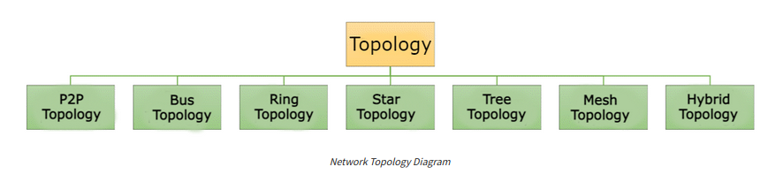

Let’s learn each topology in detail:

Point to Point (P2P)
Point-to-point topology is the easiest of all the network topologies. In this method, the network consists of a direct link between two computers.
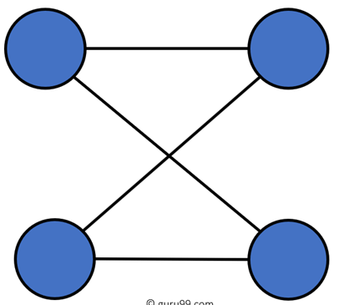

Advantages
- This is faster and highly reliable than other types of connections since there is a direct connection.
- No need for a network operating system
- Does not need an expensive server as individual workstations are used to access the files
- No need for any dedicated network technicians because each user sets their permissions

Disadvantages
- The biggest drawback is that it only be used for small areas where computers are in close proximity.
- You can’t back up files and folders centrally
- There is no security besides the permissions. Users often do not require to log onto their workstations.

Bus Topology
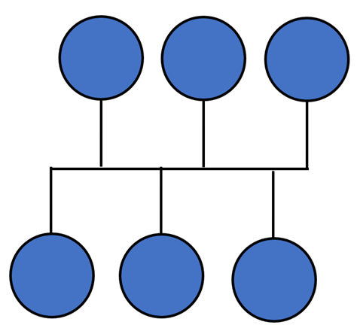

Bus topology uses a single cable which connects all the included nodes. The main cable acts as a spine for the entire network. One of the computers in the network acts as the computer server. When it has two endpoints, it is known as a linear bus topology.

Advantages
Here are pros/benefits of using a bus topology:
- Cost of the cable is very less as compared to other topology, so it is widely used to build small networks.
- Famous for LAN network because they are inexpensive and easy to install.
- It is widely used when a network installation is small, simple, or temporary.
- It is one of the passive topologies. So computers on the bus only listen for data being sent, that are not responsible for moving the data from one computer to others.

Disadvantages
Here are the cons/drawbacks of bus topology:
- In case if the common cable fails, then the entire system will crash down.
- When network traffic is heavy, it develops collisions in the network.
- Whenever network traffic is heavy, or nodes are too many, the performance time of the network significantly decreases.
- Cables are always of a limited length.

Ring Topology
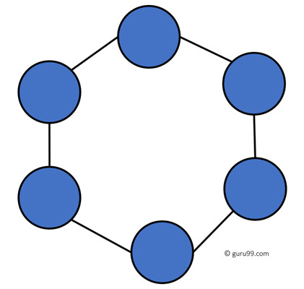

In a ring network, every device has exactly two neighboring devices for communication purpose. It is called a ring topology as its formation is like a ring. In this topology, every computer is connected to another computer. Here, the last node is combined with a first one.
This topology uses token to pass the information from one computer to another. In this topology, all the messages travel through a ring in the same direction.

Advantages
Here are pros/benefits of ring topology:
- Easy to install and reconfigure.
- Adding or deleting a device in-ring topology needs you to move only two connections.
- The troubleshooting process is difficult in a ring topology.
- Failure of one computer can disturb the whole network.
- Offers equal access to all the computers of the networks
- Faster error checking and acknowledgment.

Disadvantages
Here are drawbacks/cons of ring topology:
- Unidirectional traffic.
- Break in a single ring can risk the breaking of the entire network
- Modern days high-speed LANs made this topology less popular.
- In the ring, topology signals are circulating at all times, which develops unwanted power consumption.
- It is very difficult to troubleshoot the ring network.
- Adding or removing the computers can disturb the network activity.

Star Topology
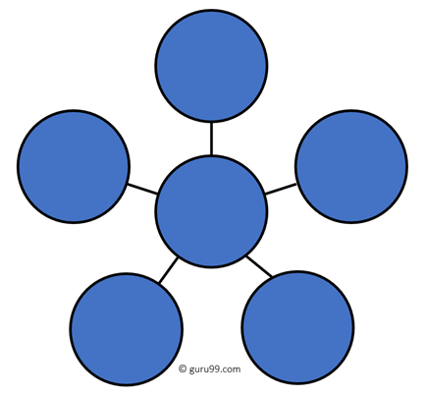

In the star topology, all the computers connect with the help of a hub. This cable is called a central node, and all other nodes are connected using this central node. It is most popular on LAN networks as they are inexpensive and easy to install.

Advantages
Here are pros/benefits of start topology:
- Easy to troubleshoot, set up, and modify.
- Only those nodes are affected, that has failed. Other nodes still work.
- Fast performance with few nodes and very low network traffic.
- In Star topology, addition, deletion, and moving of the devices are easy.

Disadvantages
Here are cons/drawbacks of using Star:
- If the hub or concentrator fails, attached nodes are disabled.
- Cost of installation of star topology is costly.
- Heavy network traffic can sometimes slow the bus considerably.
- Performance depends on the hub’s capacity
- A damaged cable or lack of proper termination may bring the network down.

Mesh Topology
The mesh topology has a unique network design in which each computer on the network connects to every other. It is develops a P2P (point-to-point) connection between all the devices of the network. It offers a high level of redundancy, so even if one network cable fails, still data has an alternative path to reach its destination.

Types of Mesh Topology

Partial Mesh Topology: In this type of topology, most of the devices are connected almost similarly as full topology. The only difference is that few devices are connected with just two or three devices.
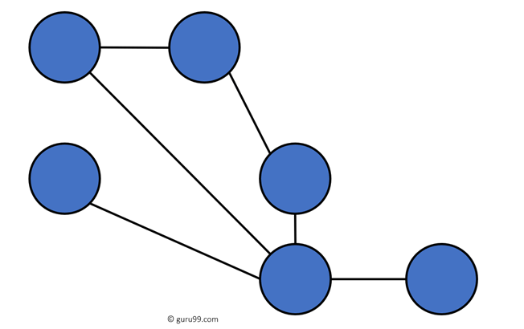

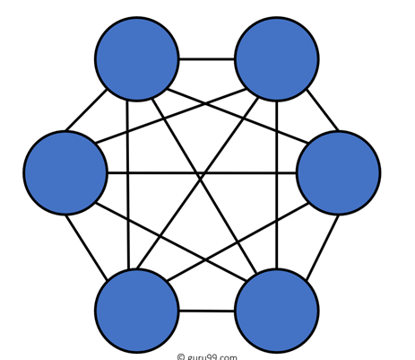
Full Mesh Topology: In this topology, every nodes or device are directly connected with each other.

Advantages
Here, are pros/benefits of Mesh topology
- The network can be expanded without disrupting current users.
- Need extra capable compared with other LAN topologies.
- No traffic problem as nodes has dedicated links.
- Dedicated links help you to eliminate the traffic problem.
- A mesh topology is robust.
- It has multiple links, so if any single route is blocked, then other routes should be used for data communication.
- P2P links make the fault identification isolation process easy.
- It helps you to avoid the chances of network failure by connecting all the systems to a central node.
- Every system has its privacy and security.

Disadvantages
- Installation is complex because every node is connected to every node.
- It is expensive due to the use of more cables. No proper utilization of systems.
- Complicated implementation.
- It requires more space for dedicated links.
- Because of the amount of cabling and the number of input-outputs, it is expensive to implement.
- It requires a large space to run the cables.

Tree Topology
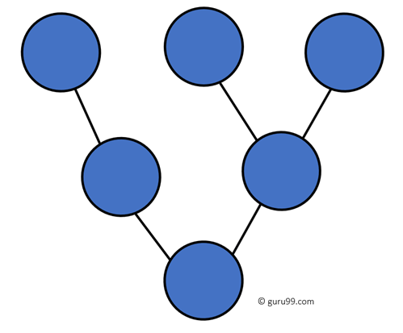

Tree topologies have a root node, and all other nodes are connected which form a hierarchy. So it is also known as hierarchical topology. This topology integrates various star topologies together in a single bus, so it is known as a Star Bus topology. Tree topology is a very common network which is similar to a bus and star topology.

Advantages
Here are pros/benefits of tree topology:
- Failure of one node never affects the rest of the network.
- Node expansion is fast and easy.
- Detection of error is an easy process
- It is easy to manage and maintain

Disadvantages
Here are cons/drawback of tree topology:
- It is heavily cabled topology
- If more nodes are added, then its maintenance is difficult
- If the hub or concentrator fails, attached nodes are also disabled.

Hybrid Topology
Hybrid topology combines two or more topologies. You can see in the above architecture in such a manner that the resulting network does not exhibit one of the standard topologies.
For example, as you can see in the above image that in an office in one department, Star and P2P topology is used. A hybrid topology is always produced when two different basic network topologies are connected.
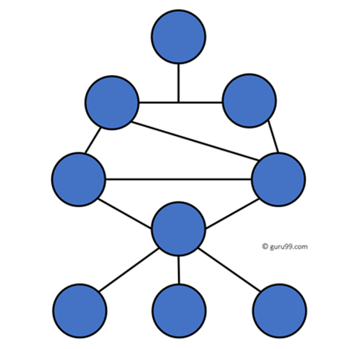

Advantages
Here, are advantages/pros using Hybrid topology:
- Offers the easiest method for error detecting and troubleshooting
- Highly effective and flexible networking topology
- It is scalable so you can increase your network size

Disadvantages
- The design of hybrid topology is complex
- It is one of the costliest processes

What is a Computer Network?
A Computer Network is a group of two or more interconnected computer systems that use common connection protocols for sharing various resources and files. You can establish a computer network connection using either cable or wireless media. Every network involves hardware and software that connects computers and tools.

Different Types of Computer Networks
There are various types of Computer Networking options available. The classification of network in computers can be done according to their size as well as their purpose.
The size of a network should be expressed by the geographic area and number of computers, which are a part of their networks. It includes devices housed in a single room to millions of devices spread across the world. Following are the popular types of Computer Network:
Some of the most popular computer network types are:
- PAN (Personal Area Network)
- LAN (Local Area Network)
- MAN (Metropolitan Area Network)
- WAN (Wide Area Network)
Let’s study all of these types of networking in detail.

What is PAN (Personal Area Network)?
PAN (Personal Area Network) is a computer network formed around a person. It generally consists of a computer, mobile, or personal digital assistant. PAN can be used for establishing communication among these personal devices for connecting to a digital network and the internet.

Characteristics of PAN
Below are the main characteristics of PAN:
- It is mostly personal devices network equipped within a limited area.
- Allows you to handle the interconnection of IT devices at the surrounding of a single user.
- PAN includes mobile devices, tablet, and laptop.
- It can be wirelessly connected to the internet called WPAN.
- Appliances use for PAN: cordless mice, keyboards, and Bluetooth systems.

Advantages of PAN
Here are the important pros/benefits of PAN network:
- PAN networks are relatively secure and safe
- It offers only short-range solution up to ten meters
- Strictly restricted to a small area

Disadvantages of PAN
Here are the cons/drawbacks of using PAN network:
- It may establish a bad connection to other networks at the same radio bands.
- Distance limits.

What is a LAN (Local Area Network)?
A Local Area Network (LAN) is a group of computer and peripheral devices which are connected in a limited area such as school, laboratory, home, and office building. It is a widely useful network for sharing resources like files, printers, games, and other application. The simplest type of LAN network is to connect computers and a printer in someone’s home or office. In general, LAN will be used as one type of transmission medium. It is a network which consists of less than 5000 interconnected devices across several buildings
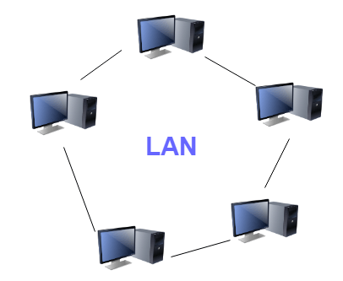

Characteristics of LAN
Here are the important characteristics of a LAN network:
- It is a private network, so an outside regulatory body never controls it.
- LAN operates at a relatively higher speed compared to other WAN systems.
- There are various kinds of media access control methods like token ring and ethernet.

Advantages of LAN
- Computer resources like hard-disks, DVD-ROM, and printers can share local area networks. This significantly reduces the cost of hardware purchases.
- You can use the same software over the network instead of purchasing the licensed software for each client in the network.
- Data of all network users can be stored on a single hard disk of the server computer.
- You can easily transfer data and messages over networked computers.
- It will be easy to manage data at only one place, which makes data more secure.
- Local Area Network offers the facility to share a single internet connection among all the LAN users.

Disadvantages of LAN
- LAN will indeed save cost because of shared computer resources, but the initial cost of installing Local Area Networks is quite high.
- The LAN admin can check personal data files of every LAN user, so it does not offer good privacy.
- Unauthorized users can access critical data of an organization in case LAN admin is not able to secure centralized data repository.
- Local Area Network requires a constant LAN administration as there are issues related to software setup and hardware failures

What is WAN (Wide Area Network)?
WAN (Wide Area Network) is another important computer network that which is spread across a large geographical area. WAN network system could be a connection of a LAN which connects with other LAN’s using telephone lines and radio waves. It is mostly limited to an enterprise or an organization.
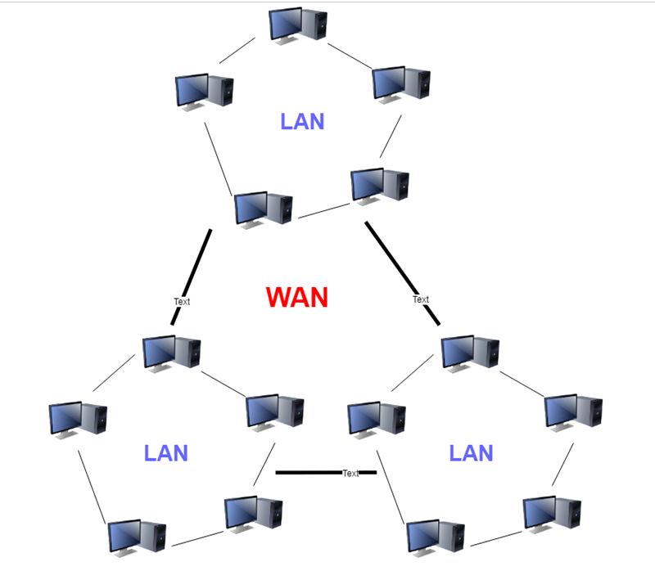

Characteristics of WAN
- The software files will be shared among all the users; therefore, all can access to the latest files.
- Any organization can form its global integrated network using WAN.

Advantages of WAN
- WAN helps you to cover a larger geographical area. Therefore business offices situated at longer distances can easily communicate.
- Contains devices like mobile phones, laptop, tablet, computers, gaming consoles, etc.
- WLAN connections work using radio transmitters and receivers built into client devices.

Disadvantages of WAN
- The initial setup cost of investment is very high.
- It is difficult to maintain the WAN network. You need skilled technicians and network administrators.
- There are more errors and issues because of the wide coverage and the use of different technologies.
- It requires more time to resolve issues because of the involvement of multiple wired and wireless technologies.
- Offers lower security compared to other types of network in computer.

What is MAN (Metropolitan Area Network)?
A Metropolitan Area Network or MAN is consisting of a computer network across an entire city, college campus, or a small region. This type of network is large than a LAN, which is mostly limited to a single building or site. Depending upon the type of configuration, this type of network allows you to cover an area from several miles to tens of miles.
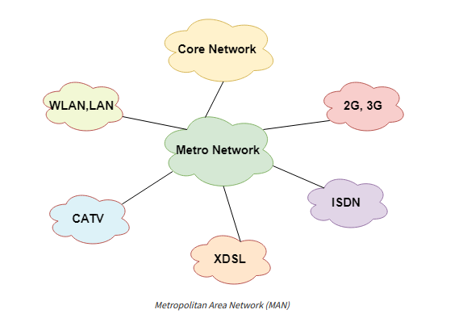

Characteristics of MAN
Here are important characteristics of the MAN network:
- It mostly covers towns and cities in a maximum 50 km range
- Mostly used medium is optical fibers, cables
- Data rates adequate for distributed computing applications.

Advantages of MAN
Here are the pros/benefits of MAN network:
- It offers fast communication using high-speed carriers, like fiber optic cables.
- It provides excellent support for an extensive size network and greater access to WANs.
- The dual bus in MAN network provides support to transmit data in both directions concurrently.
- A MAN network mostly includes some areas of a city or an entire city.

Disadvantages of MAN
Here are drawbacks/cons of using the MAN network:
- You need more cable to establish MAN connection from one place to another.
- In MAN network it is tough to make the system secure from hackers

Other Types of Computer Networks
Apart from above mentioned computer networks, here are some other important types of networks:
- WLAN (Wireless Local Area Network)
- Storage Area Network
- System Area Network
- Home Area Network
- POLAN- Passive Optical LAN
- Enterprise private network
- Campus Area Network
- Virtual Area Network
Let’s see all these different types of networks in detail:

1) WLAN
WLAN (Wireless Local Area Network) helps you to link single or multiple devices using wireless communication within a limited area like home, school, or office building. It gives users an ability to move around within a local coverage area which may be connected to the network. Today most modern day’s WLAN systems are based on IEEE 802.11 standards.

2) Storage-Area Network (SAN)
A Storage Area Network is a type of network which allows consolidated, block-level data storage. It is mainly used to make storage devices, like disk arrays, optical jukeboxes, and tape libraries.

3) System-Area Network
System Area Network is used for a local network. It offers high-speed connection in server-to-server and processor-to-processor applications. The computers connected on a SAN network operate as a single system at quite high speed.

4) Passive Optical Local Area Network
POLAN is a networking technology which helps you to integrate into structured cabling. It allows you to resolve the issues of supporting Ethernet protocols and network apps.
POLAN allows you to use optical splitter which helps you to separate an optical signal from a single-mode optical fiber. It converts this single signal into multiple signals.

5) Home Area Network (HAN)
A Home Area Network is always built using two or more interconnected computers to form a local area network (LAN) within the home. For example, in the United States, about 15 million homes have more than one computer.
These types of network connections help computer owners to interconnect with multiple computers. This network allows sharing files, programs, printers, and other peripherals.

6) Enterprise Private Network
Enterprise private network (EPN) networks are build and owned by businesses that want to securely connect numerous locations in order to share various computer resources.

7) Campus Area Network (CAN)
A Campus Area Network is made up of an interconnection of LANs within a specific geographical area. For example, a university campus can be linked with a variety of campus buildings to connect all the academic departments.

8) Virtual Private Network
A VPN is a private network which uses a public network to connect remote sites or users together. The VPN network uses “virtual” connections routed through the internet from the enterprise’s private network or a third-party VPN service to the remote site.

Types of Servers in Computer Networks: 15 Different Types
A server is a piece of computer hardware or software that provides functionality for other programs and devices. It provides various functionalities, often called services such as sharing data or resources among multiple clients or performing computation for client. Single server can serve multiple clients, and a single client can use multiple servers.
There are many types of servers are available in the market which we will discuss in the article. Here are the

What are the Different Types of Servers?

Database Servers
- They’re used to store and distribute different databases via a network. A database is a structured data set with preset characteristics that you can present in a table.
- Database servers’ customers include accounting applications, spreadsheets, and any other software application that needs access to well-structured data in large quantities. With this type of server, you can regularly back up your information from a specific location.
- However, database servers are prone to security breaches, so implementing high-level security and protection measures is essential.

Email Servers
- A mail server processes and distributes email messages through a network. It’s a service that accepts messages sent by email clients and forwards them to another server. In addition, it transmits emails to end-user devices such as personal computers found in homes and offices.
- Email servers typically utilize the Simple Mail Transfer Protocol (SMTP). Although modern mail servers support additional protocols, SMTP is still widely used. The most common configuration for email servers today is combining them with web servers. That permits clients to display data in a graphical format on a website.
- Email servers are more popular with businesspeople because they support bulk email distribution. Furthermore, their unique security system filters outgoing and incoming spam.

Web Proxy Server
- There are different protocols that a web proxy server can operate on, though they serve the same purpose. Their job is to accept customer requests, sort them, and take action on their behalf. The most common use for a web proxy server is to bypass web filters at work or school.
- The filters permit users to access restricted websites by routing all web traffic through a single IP address and an open webpage. Web proxy servers are similar to organizational servers but don’t require authorization from the institution. It collects a user’s browser data, logs it for subsequent analysis, and sends it to the internet.
- That aggregates all users’ information, rendering all computers indistinguishable. Consequently, a company can proactively protect its customers from being singled out, monitor the store, and evaluate all outgoing and incoming data traffic.

DNS Server
- A DNS server’s primary function is converting domain names to their matching IP addresses. It also ensures that users don’t have to remember IP addresses and that businesses get relevant brand names. Most users’ DNS servers come from their respective internet service providers.
- Nevertheless, several businesses offer this search at no cost. Individuals particularly mindful of safeguarding their online anonymity often turn to these secondary DNS providers. The grouping of DNS servers follows a hierarchy, with some being more reliable than others.

FTP Server
- The File Transfer Protocol (FTP) server’s sole function is facilitating user-to-user file transfers.
- After successful authentication via an FTP client, clients get permission to upload and receive files from the server. They can also access the server’s contents and obtain any file they like.

Fax Servers
- These servers use a network to share single or multiple fax machines, eliminating the need for individual users to access a fax machine directly. Their customers are individuals who send or receive faxes regularly.

File Servers
- File servers are more sophisticated and can map networked files onto drives. It enables a person to explore folders using their PC’s file browser. The main benefit of having a server is that it allows users to submit and download shared files.
- The admin is responsible for controlling who accesses which files. File servers are commonly found in workplace networks and operate in Linux or Windows Active Directory settings.

DHCP Servers
- The server utilizes the Dynamic Host Communication Protocol (DHCP) to set up a user’s PC network settings.
- They automatically customize these network settings to LAN computers, saving IT admins the trouble of assigning manual IP addresses and other network settings for each user’s computer.

Print Server
- A print server establishes a remote connection with nearby computers through which multiple users can print.
- They allow companies to distribute one printer among numerous workgroups. Specific printer models contain built-in servers, just waiting to be connected to a network when you set them up in a workplace.

Proxy Server
- The server relays customer requests for resources to servers that host such resources. When sending requests, it acts on the users’ behalf, masking their IP address from the resource server.
- Proxy servers have many applications, including content filtering, error correction, authentication, recording, and monitoring.

Application Server
- Application servers bridge the gap between database servers and the end user. They permit clients to get apps without downloading them on their devices. Because they can efficiently host large quantities of application data for multiple users simultaneously, they stand as the best option for commercial use.

Catalog Server
- Catalog servers keep track of a list of contents for information dispersed throughout an extensive network. A vast area network may comprise server-hosted files, web-based applications, users, and computers.
- Any computer application that needs to locate data on a network is a potential customer. Examples might include an email client searching for a contact or a user trying to find a file.

Web Server
- A Web server’s primary function is hosting websites. They accept requests via the Hypertext Transfer Protocol (HTTP), which helps with website distribution. Web browsers start communication with servers by sending requests via HTTP. That results in the computer sending back the requested data. They take in and store user agent-sent data.
- Generally, web servers do not have a graphical user interface. That keeps the server’s memory from depleting and guarantees sufficient energy to power the server apps and operating system.
- The servers act as content delivery systems. Furthermore, they’re capable of running any program imaginable. As long as they follow the standard rules of the internet, they can function properly on different operating systems.

Communications Server
- These servers create the necessary atmosphere for one communication endpoint to search for and establish contact with other endpoints.
- Contingent on the network’s accessibility and security settings, these servers might or might not offer a location-tracking function and a directory of communication endpoints.

Computing Server
- Computing servers pool vast processing power, including central processing units and random-access memories over a network.
- Any application that necessitates more processing speed and memory than a typical home computer would benefit from such servers.

Dedicated Server
- A dedicated server is used for hosting a single program or service, which companies may hire for usage via the internet or an internal intranet. An external service provider handles it is hosting and management. When you hire a dedicated server, no other client or company can have access to it.

Shared Server
- A shared server stores your data and programs alongside other users or companies. Typically, you pay a set monthly fee in exchange for a certain bandwidth and storage space allocation. You’ll have to pay more for the extra allocation if you go above your limits.

VPS Server
- A VPS (virtual server) mimics a dedicated physical server’s performance. It’s a separate space within a physical server expressly available to end users. Reallocating resources and adjusting to changing workloads becomes much easier with a virtual servers.

Why do we need Network Model ?
🔧 1. Structure Representation
- What it does: It maps relationships between different components or nodes.
- Why it's needed: Complex systems (like the internet, social networks, or supply chains) can't be understood just by looking at individual parts. We need to see how they connect.

🌐 2. Efficient Communication and Routing
- In networking: A network model helps design data flow (e.g., in the Internet or computer networks).
- Why it's needed: It ensures data reaches its destination efficiently, avoiding bottlenecks or failures.

🧠 3. Problem Solving and Optimization
- Examples: Finding the shortest path (like Google Maps), detecting communities in social networks, or load balancing.
- Why it's needed: Helps in decision-making and improves performance across various systems.

🔬 4. Simulation and Prediction
- Used in: Epidemiology (spread of disease), traffic flow, or power grid analysis.
- Why it's needed: You can simulate real-world behavior and predict outcomes without costly experiments.

📊 5. Data Modeling (in Databases)
- In database systems: Network models (especially older database models) represent complex relationships better than hierarchical or flat models.
- Why it's needed: For queries that involve many-to-many relationships or intricate linkages between data.

🧬 6. Understanding Relationships
- Used in: Social network analysis, neural networks, gene interaction networks.
- Why it's needed: To uncover hidden patterns, central influencers, or weaknesses in the system.

Before the development of modern network models (like the OSI or TCP/IP models), communication systems still existed—but they were much more limited, proprietary, and less standardized. Here's how communication was happening:

1. Point-to-Point Communication
Early communication systems operated mainly in a point-to-point manner:
- A direct link was established between two devices.
- Examples:
  - Telegraph systems (e.g., Morse code)
  - Telephone networks
  - Serial communication (RS-232)
There was no standard model defining layers or separating concerns like today.

2. Proprietary Protocols
Each vendor or organization often created custom communication protocols for their devices:
- These were not interoperable.
- Manufacturers like IBM had their own networking systems (e.g., IBM's SNA - Systems Network Architecture).
- Communication relied on very specific configurations.

3. Circuit-Switched Networks
Used mainly in telephone systems:
- A dedicated communication path was established for the duration of a call or session.
- The path stayed open until the communication ended.
- Not efficient for data communication.

4. Manual Processes
- Message switching was used in telegraph networks, where messages were manually routed.
- Operators would read, write, and re-send messages along different network hops.

5. No Layered Model
- Communication involved sending bits over wires without standard abstraction layers.
- Everything was "monolithic"—applications handled all aspects of communication (timing, error correction, addressing, etc.) themselves.

Why Network Models Were Introduced
- Lack of interoperability
- Complexity in designing communication systems
- The need for modularity and reusability
- The rise of the Internet and packet-switched networks
This led to the OSI model (developed in the 1980s) and the TCP/IP model, which define standard layers (like physical, data link, network, etc.) and protocols for modern networking.

✅ Key Network Models You Should Know

🔹 1. OSI Model (Open Systems Interconnection)
- Purpose: Conceptual framework to understand and design network systems in 7 layers.
- Why It Matters: Essential for analyzing traffic, logs, and security events layer by layer in SOC.
- Layers: Physical → Data Link → Network → Transport → Session → Presentation → Application

🔹 2. TCP/IP Model (Internet Protocol Suite)
- Purpose: Real-world model used for designing and implementing internet and network communications.
- Why It Matters: Forms the basis of modern networking (e.g., IP, TCP, UDP, HTTP).
- Layers: Link → Internet → Transport → Application

🔹 3. Client-Server Model
- Purpose: Defines a centralized model where clients request services from a server.
- Why It Matters: Common architecture for web services, email, databases — target for many attacks.

🔹 4. Peer-to-Peer (P2P) Network Model
- Purpose: All nodes act as both client and server.
- Why It Matters: Used in file sharing (e.g., BitTorrent), malware distribution, and botnets.

🔹 5. Hybrid Network Model
- Purpose: Mixes client-server and P2P characteristics.
- Why It Matters: Found in complex enterprise or cloud environments; needs flexible security monitoring.

🔹 6. Zero Trust Network Model
- Purpose: “Never trust, always verify” approach; enforces least privilege.
- Why It Matters: Rising standard in modern SOCs to stop lateral movement and insider threats.

🔹 7. Network Database Model (CODASYL)
- Purpose: Early database model where entities are connected via pointers.
- Why It Matters: Historical but foundational to understanding complex relational structures in data.

🔹 8. Software-Defined Networking (SDN) Model
- Purpose: Separates control plane from data plane in network hardware.
- Why It Matters: Allows dynamic, programmable network management; new attack surfaces too.

🔹 9. Overlay Network Model
- Purpose: Logical networks built on top of physical networks (e.g., VPNs, Tor).
- Why It Matters: Used in anonymized traffic, secure communication, and malware obfuscation.

🔹 10. Service-Oriented Architecture (SOA) / Microservices Model
- Purpose: Applications composed of small, independent services.
- Why It Matters: Requires security visibility across multiple APIs and services.

🔹 11. Cloud Network Models (IaaS / PaaS / SaaS)
- Purpose: Defines how services are delivered over the cloud.
- Why It Matters: Each has different security responsibilities — shared responsibility model.

🔹 12. Network Function Virtualization (NFV) Model
- Purpose: Replaces hardware-based network functions (like firewalls) with virtual versions.
- Why It Matters: Common in modern SOCs using virtual appliances for scaling and speed.

The "New Era" model of networking doesn't refer to a single, formal replacement of models like OSI or TCP/IP, but rather to a paradigm shift in how networks are designed, operated, and experienced—driven by modern technologies such as cloud computing, AI, 5G, and software-defined systems.
Here’s a breakdown of what defines this new era of networking:

🔁 1. Software-Defined Networking (SDN)
- Control plane is separated from the data plane.
- Networks are programmable, allowing centralized control and automation.
- Reduces reliance on vendor-specific hardware.
- Example: OpenFlow, Cisco ACI.

☁️ 2. Cloud-Native Networking
- Built for cloud environments (AWS, Azure, GCP).
- Highly scalable, automated, and elastic.
- Uses microservices, containers (Kubernetes), and APIs to manage networks dynamically.

🧠 3. AI/ML-Driven Networks
- Uses AI and machine learning for:
  - Network monitoring
  - Anomaly detection
  - Predictive maintenance
  - Traffic optimization
- Enables self-healing and self-optimizing networks.

🌐 4. Zero Trust Architecture (ZTA)
- Assumes no inherent trust, even inside the network.
- Every access request is verified and authenticated.
- Key to modern cybersecurity frameworks.
- Uses techniques like micro-segmentation, identity-aware proxies, and strong encryption.

📶 5. 5G and Edge Networking
- 5G introduces:
  - Ultra-low latency
  - Network slicing
  - Massive IoT support
- Edge computing moves data processing closer to users/devices to reduce latency.

🔐 6. Secure Access Service Edge (SASE)
- Combines networking (WAN) and security (e.g., firewall, ZTNA) into a cloud-delivered service.
- Key for remote work, IoT, and mobile-first environments.

🔗 7. Intent-Based Networking (IBN)
- You define the desired business intent (e.g., "prioritize video traffic").
- The network automatically configures and adjusts itself to fulfill that intent.
- Uses AI, policy engines, and automation.

🛰️ 8. Network as a Service (NaaS)
- Networking is delivered as a subscription-based cloud service.
- Reduces the need for owning and maintaining infrastructure.
- On-demand, scalable, and highly flexible.

